Complete Rig Camp Accommodation.

Type of construction:

Mono block with high endurance desert climatic conditions that can moved in all kind of terrain and in ambient temperature from -5 degrees to + 55 degrees extra heavy duty construction Fire proof

Structure
- The structure will be completely steel type, designed to withstand all loads foreseen during the various operating phases of cabins: constructions, lifting transportation installation and operation.
- Co2 Gas fully welding is preferred to ensure the quality of welding and a perfect air and water seal
- Basic structure Standard steel section according calculation note.
- Structure quadrangular: This structure connected by point of centering and continuous welding under inner gas in order to adapt to all expensive vibration during transport and with impact building site.

External walls side:

- Total thickness 100 mm made up off
- Sheet external thickness 2mm galvanized and reinforced with a layer to proceed (fixing on galvanize) and 2 top coats.
- Insulating materials Thermo acoustic with rock wool classified M10 deprived of any irritating matter
- Inner wall panels in me-laminated resin balanced to avoid categorically any distortion due to transportation and temperature constraint. (Beige color)

Floor insulates via Rockwell aggregate of high density.

- Total thickness 100mm fixed on metal mesh allowing load uniformity disturbed of 800KG.cubic meter.
- Compound compost of
- Galvanized sheet external of Nerves co type. (Corrugated galvanized steel plates same as of the shipping containers)
- Rock wool 150 kg/cubic meter of density
- Hot rolled and treated sheet thickness 5mm on stiffer
- Vinyl layer 4mm thick in the sleeper’s rooms.

Roof and ceiling
- Same characteristic of the side walls
- Covering is made by a frame in steel drawn tubes installed all along the parameter and but weld to the corner fittings. Longitudinally along the centerline a drawn tube is installed as such level to originate a 50mm slope toward the long side of the roof to both pitches.
- Galvanized sheet external of Nerves co type. (Corrugated galvanized steel plates same as of the shipping containers
- Ceiling metal sheet with free space allowing spontaneous the air to circulate at the roof.
- Covering minimum capacity is 4 KN/sq meter.
- Made off:
- External Sheet thickness 2mm galvanized and reinforced with a layer to proceed (fixing on galvanize) and 2 top coats.

- Total thickness 100 mm made up off
- Inner wall panels in me laminated resin balanced to avoid categorically any distortion due to transportation and temperature constraint
- Insulating materials Thermo acoustic with rock wool classified M10 deprived of any irritating matter.

Sound proofing
- The external walls and the floor will have an attenuation of noise of 38Db with the airborne noise and of 48db with noises of impact.
- Windows is anodized aluminum type
- Windows is a fixed type (Single or double) Complete of shatter proof double glazing glasses.

External doors, Single leaf doors
- Fire proof with double metal walls cuts fire, with standardized dust –protecting joint.
- A certificate of Authenticity for each input
- They are out of galvanized steel with double walls (box) the interior is filled with an insulator who,s thermal resistance determines the thickness in order to obtain the value of fire proofing.
- Layer of phonic insulator 40mm thick to be standardize with clean walls of the cabin.
- The executives of the doors are out of independent steel with the bearing structure.
- The doors are equipped with joints with sufficient compression the over pressure of air conditioning.
- These doors are provided with Heavy duty locks anti panics. ( Require extra locks)

Out side doors should be installed with 4 heavy duty hinges on each door.(SameAs picture)
• 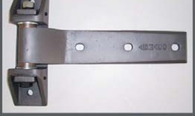 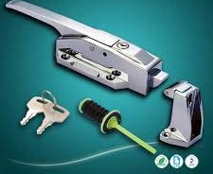

Lifting and moving.
- The lifting of the units will be done by crane using 4 shackles at the four static points of slinging and
- Also by bed truck using winch line,

Electrical circuit
- Single phase current 220 volts – 50Hz, with line of ground and protection by differential circuit breakers.
- Maximum capacity to make the function of all the electric components at the same time with safety factor of 25%.
- Lighting By light fixtures and neon tube, respecting the number of the conventional lux.

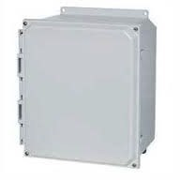
Outside electrical junction box, on each unit 30 cm x 30 cm

Sanitary

- Team’s toilets, wash hand basin. Mirrors of door soap carries towel distribution of toilet paper.
- Hot water, cold water and drain installation
- All hot water heaters will be installed on the outside of the cabins
- Ventilation

Doors and windows notes And measurements

  - Outside kitchen door 203 cm x 105cm wide including the frame
  - Sleeper rooms outside doors 203 cm x 85cm wide including the frame
  - Deep freeze outside door 200cm x 90cm opening plus the frame

  - Laundry 203cm x 105 cm including the frame
  - Sleepers Rooms internal doors, 190 cm x 70cm

    - Office windows. 80CM X 60CM WIDE. The windows start 90cm from the floor

    - All fiber glass flooring should be 10mm thick should be strong and smooth surface

    - All outside steps should be hinged, and safety chain to be installed for moving

18 each 28' x 10' 4 - Men Sleeper.
Reference No 1.
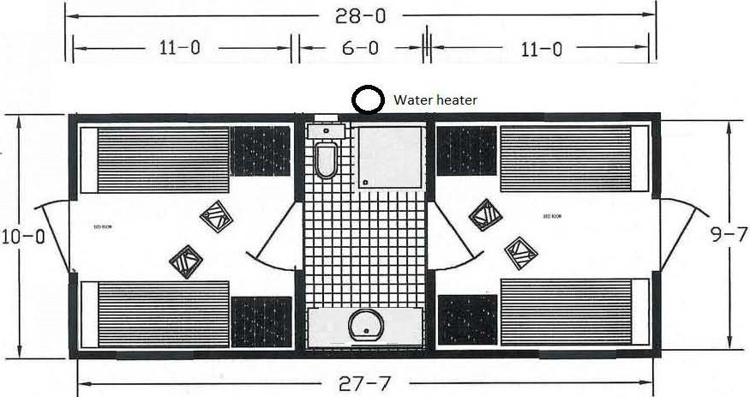

18 | Ea | 28ft X 10 ft 4 men sleeper units (2 bed rooms  and bathroom) complete with the following
4 | Ea | 900 x 2000mm Single heavy duty wood beds
 |  | with bunk light and shelf
4 | Ea | Mattress
4 | Ea | Folding chairs
4 | Ea | Wardrobe locker, 2 doors
2 | Ea | Coat hooks , set of 5
1 | Ea | 80 liters water heater, to be installed out side
1 | Ea | 600 X 400MM Mirrors, lights, soap tray
 |  | and shelves
1 | Ea | 300 x 300mm Exhaust fan with rain proof vent
2 | Ea | LG or Hommer 12,000 BTU split type air condition,
1 | Ea | Wash hand basin fiber glass (Same as picture
4 | Ea | Waste basket
2 | Ea | Heavy duty PVC doors between the sleeper  rooms and shower room with locks
3 | Ea | Emergency lights,(Sleeper rooms and shower  Room)
1 | Ea | Towel hanger
1 | Ea | Toilet hose
2 | Ea | Smoke detectors
4 | Ea | Wall plugs in every sleeper
1 | Ea | Shower unit fiber glass fabricated that will not
 |  | allows any water seeping to the sleepers units

Notes regarding Sleepers rooms

- Sleeper’s unit’s walls and roof will be made of 16mm thick white melamine board to ensure the pressure of the press seam formation.
- The sleepers rooms floor will be covered with 3mm thick Vinyl layer
- In the shower rooms layout to ensure that the lowest position in the drain and “U” tube design to prevent any water leaking. (The “U” drain has to be made from brass and not plastic.) The “U” Drain has to be separate from the sewage lines.
- The wall in the shower room has to be built from plastic board.
- The plastic boards have to be joint in a way that no water leaking.
- The shower cubicle has to be fabricated in one piece from heavy duty fiber glass and have to make sure that no water will leak from the drain or the shower cubicle into the sleeper’s rooms. (Same as picture below)
- all the water lines will be of ¾” and
- Water heaters must be installed outside the units
- Sewage line should be of 110mm (GM)
- The floor of the shower room will be made from 8mm thick fibre glass coming 4 inches on the wall to prevent any water from seeping between the walls and shower room

Note the toilet room floor must be of 10mm fiberglass material must go up 10 cm to the walls to prevent any water seeping to the sleeping rooms from both the shower stall or the shower room
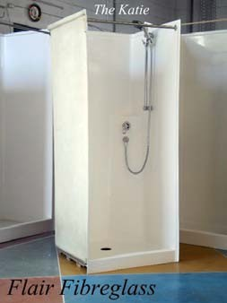
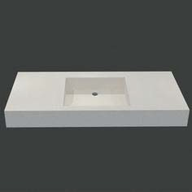
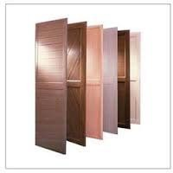
Internal heavy duty PVC doors with locks

Fiber glass Shower cubicle Fiber glass wash hand basin, The fiber glass on the basin should continue with 25 cm high along side of the basin walls to prevent damage on the side walls from water splashing

1 each 28’ X 30’ Kitchen/Diner Complete.
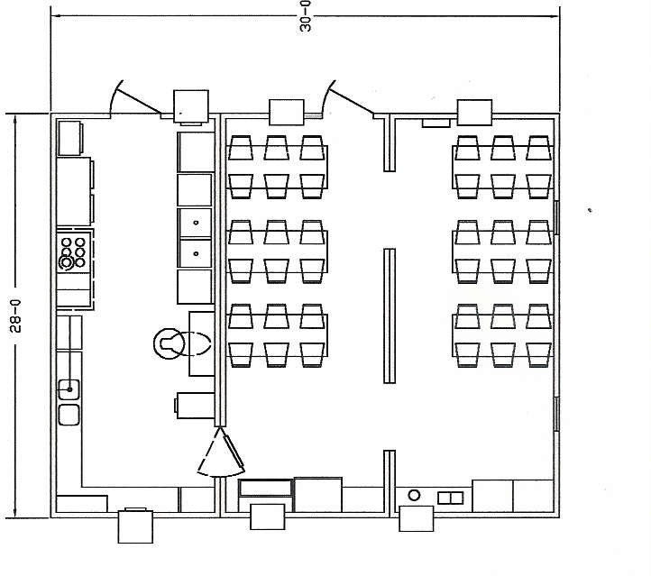
Reference no 2.

1 | Ea | Kitchen/ diner unit (28 ft x 30 ft)
 |  | Complete with the following
8 | Ea | Heavy duty dining tables 750 x 1000mm
36 | Ea | Steel folding chairs
2 | Ea | Refrigirators 150 liters caoacity
1 | Ea | Water heater 200 liters
1 | Ea | Ice cream machine
2 | Ea | Juice dispencer
1 | Ea | Meat grinder (Italy Made)
1 | Ea | Meat sclicer
1 | Ea | Potatoe frier industrial (Italy Made)
1 | Ea | Heavy duty Electric range 6 burner, griddle
 |  | & 2 ovens ( Italy Made ) with consumable spare parts
6 | Ea | LG or Hommer 18,000 Btu, Split typoe air conditions
 |  | 220 volts 50Htz single phase ( Hot & Cold ) complete with
 |  | connection tube
1 | Ea | Stainless sink with double basin
1 | Ea | Exhaust Hood to cover the cooking area with
 |  | 2 x 450mm fans with rain proof vent and filters
 | Ea | installed on the side wall. (6 each extra filters)
1 |  | Toast master 54" electric oven 2- Tier ( Italy Brand )
1 | Ea | Hobart mixer (10kg ) capacity w/removal
 |  | basin
6 | Ea | Emergency lights
2 | Ea | Windows 500 x 800mm in the dining area

2 | Ea | Curtains for windows
6 | Ea | Smoke detectors
4 | Ea | Hanging stainless steel cupboard with sliding
 |  | doors, along side the kitchen 1.8 meters long
4 | Ea | Stainless steel tables for kitchen
1 | Ea | ice cube make machine. International brand
 |  | with one year recommended parts complete
 |  | with manual and parts book
1 | Ea | Salad line
1 | Ea | 6 basin well bein Marie streamer/ buffet line
 |  | food warner
4 | Ea | Insect killers large for kitchen and mess hall

- The kitchen and mess hall interior floors will be made from 10mm thick fiber glass and will be will go up to 10cm on the side walls, to prevent any water seeping from between the fiber glass and the side wall.
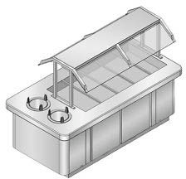
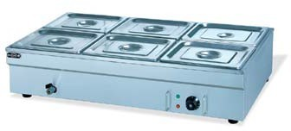
Salad Line 6 Basin Well Bain Marie streamer/ Buffet line food warmer

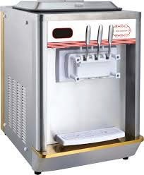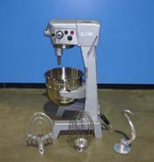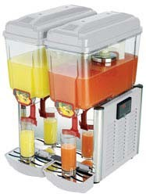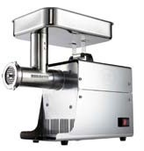

Ice cream machine

Hobart bread Mixer Juice dispenser Meat grinder

1 each Recreation rooms.

Reference no 3.

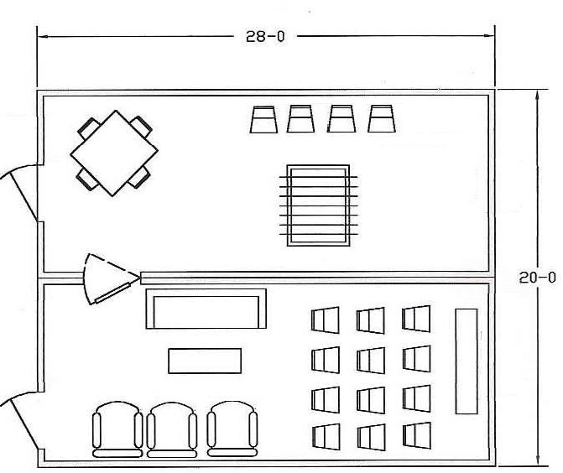

1 | Ea | 28 ft x 20 ft Recreation trailer (Game -tv room)
1 | Ea | Serving table with formica top
2 | Ea | 1 men upholstered easy chairs with arms
1 | Ea | 3 men upholstered sofa
1 | Ea | Rectangular coffee table
1 | Ea | Card table 36" x 26"
24 | Ea | Steel folding chairs
1 | Ea | Entertainment center cabinet
1 | Ea | Table soccer
4 | Ea | LG or Hommer 18,000 BTU split type air conditions 220
 |  | volts 50 Hertzs single phase
1 | Ea | Coffee makers 36 cups
1 | Ea | 50" Led tv
6 | Ea | Smoke detectors
1 | Ea | Stainless steel wash basin

The floor must be of minimum 10 mm thick fibre glass and must be going up to 100 mm on the sidewalls to prevent any water seeping to the side walls

1 each 28' X 10' Cooler/ Freezer Unit.

Reference no 4.
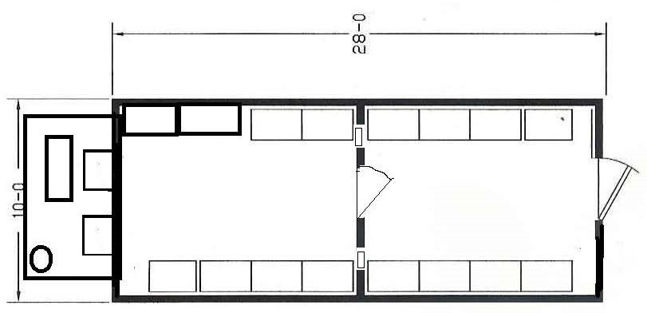

1 | Ea | 28 ft X 10 ft Cooler/freezer unit complete
1 | Ea | complete with the following  Freezer units, must be (Blitzer)
 |  | 380 volts, 50 Hz, 3-Phase semi Hermatic complete
 |  | with separate control panel for each unit.
1 | Ea | The inner units should have 2 fans each
1 | Ea | Caterpillar Diesel generator 22KVA,380v,50Hz with selector switch
1 | Ea | that will be able to run both deep freeze units
1 | Ea | 200 litres fuel tank
4 | Ea | Wall mounted stainless steel meat rack
 |  | with hooks
1 | Ea | Fir shelving (Stainless steel)
1 | Ea | Circulating fan with thermostat

- Deep freeze temperature - 20 degrees centigrade
- Groceries cooler minimum -6 degrees centigrade
- Deep freeze Compressor minimum 4 Hp
- Temperature control must be Dixell xr-60 Brand
- Free on Gas must be no 22
- Temperature gauges must be installed on the outside for both Deep freeze and cooler
- Both compressors and generator should be incorporated on the deep freeze skid and closed
- in a compartment made from Mesh plate with hinged doors to be able to service the compressors.
- Note The main skid of the deep freeze must be 25 centimeters high H beams
- The floor must be of minimum 10mm fiber glass materials and going up to 100mm on the sidewalls to prevent any water seeping to the side walls.
- Outside door must be specially built for the deep freeze unit.
- Side walls of the deep freeze must be 15 mm thick including insulation material.

1 each 28' X 10' Laundry Room .

Reference no 5.

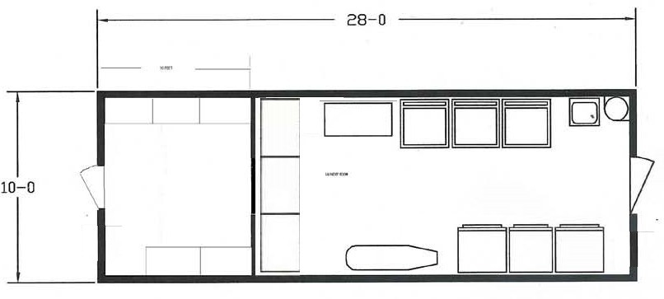

1 | Ea | 18ft x 10 ft Laundry room/10 ft x 10 ft  Storage complete with the following
3 | Ea | LG 14kg capacity washing machines
 |  | 380 volys 50 Htz 3 phase Heavy duty
3 | Ea | LG Thumble drier 14 kg capacity 380 volts
 |  | 50 Hz Heavy duty
1 | Ea | First quality Steam iron
1 | Ea | Iron board with cover
1 | Ea | Stainless steel work table
1 | Ea | Fiber glass laundry sink with faucet
1 | Ea | 18" Exhaust fan wall mounted with shutter
1 | Ea | Steel storage cabinet , 2 doors, 4 shelves
1 | Ea | Water heater 200 litres capacity
2 | Ea | LG or Hommer 12,000 Btu split type air condition
5 | Ea | Shelve section 2ft x 3 ft, 5 shelves
2 | Ea | smoke detectors

- The floor must be of minimum 10 mm fiber glass materials and going up to100 mm on the side walls to prevent any water seeping to the side walls.
- 2 years parts for both washing machines and dryers must be supplied.

28' X 10' Storage Unit.

Reference no 6.

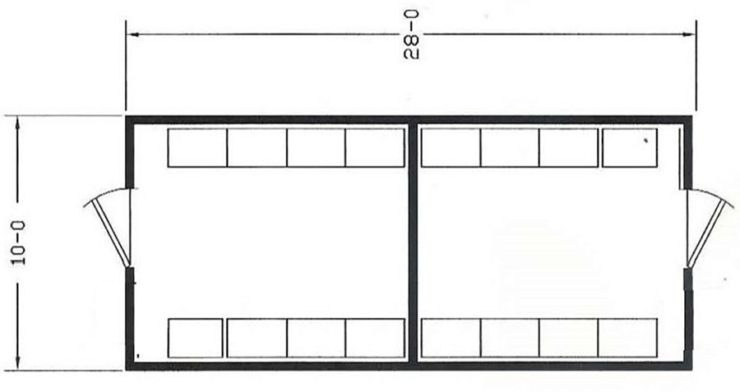

2 | Ea | 28 ft x 10 ft storage unit complete with
5 | Ea | Shelf sections 2 ft x 5 ft 5 shelves
2 | Ea | LG or Hommer 12,000 Btu split typoe air conditions
2 | Ea | 220 volts, 50 Hz single phase Smoke detectors

- The floor must be of minimum 10 mm fiber glass materials going up to 100 mmon the side walls to prevent any water seeping to the side walls.
- Side walls should be built same as sleeper rooms

1 each 28' X 10' Bakery /Storage unit.

Reference no 7.

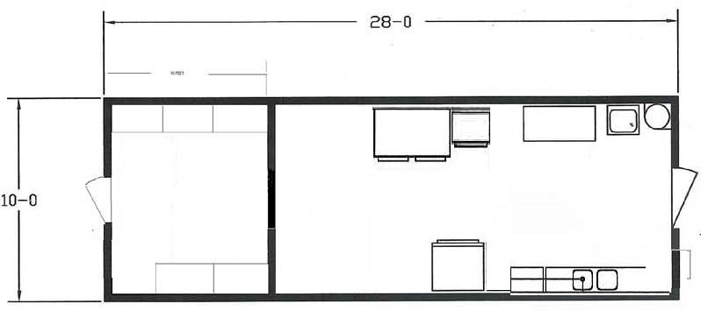

1 | Ea  Ea | 28 ft x 10 ft Bakery/storage unit  Complete with
1 | Ea | Double shelve bread oven (International brand)
 |  | LG 150 liters refrigerator
2 | Ea | 100 litres water heater
1 | Ea | Double wash hand basin , fiber glass good quality
2 | Ea | stainless steel tables
1 | Ea | bread mixer with removable basin Hobart
 |  | 10 to 15 kg
2 | Ea | LG or Hommer Split type air conditions 12,000 btu
1 | Ea | Bread warmer (Stainless steel) 220 volts
 |  | 50 Hz with 20 trays
6 | Ea | shelf sections 2 ft x 5 feet 4 shelves in storage  and 2 shelves in bakery
2 | Ea | Smoke detectors

The floor must be of minimum 10 mm fiber glass materials going up to 100 mm on the side walls to prevent any water seeping to the side walls.
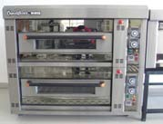
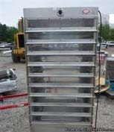

Bread warmer
Bread oven

1 each Camp boss room.

Reference no 8 .
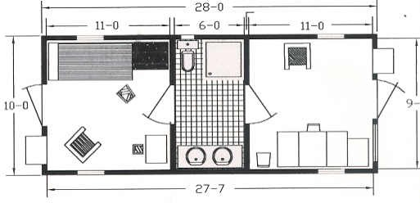

1 | Ea | 28ft X 10 ft sleeper/office units (1  bed room,
 |  | office and bathroom) complete with the following
1 | Ea | 900 x 2000mm Single heavy duty wood beds
 |  | with bunk light and shelf
1 | Ea | Mattress
2 | Ea | 4 Drawer file cabinet with lock
1 | Ea | Wardrobe locker, 2 doors
1 | Ea | 30" x 60" desk double pedestal with lock
1 | Ea | Dining table 30" x 30"
1 | Ea | Rectangular coffee table
1 | Ea | Coffee maker 36 cups capacity
1 | Ea | Refrigerator 6 cu ft capacity 50 hz
2 | Ea | Steel folding chairs
1 | Ea | office Swivel chair with arm rest padded seat
4 | Ea | Waste basket
2 | Ea | Heavy duty PVC doors between the sleeper  rooms and shower room with locks
3 | Ea | Emergency lights,(Sleeper rooms and shower  Room)
1 | Ea | Towel hanger
1 | Ea | Toilet hose
2 | Ea | Smoke detectors
4 | Ea | Wall plugs in sleeper and office
1 | Ea | Shower unit fiber glass fabricated that will not
 |  | allows any water seeping to the sleepers units
1 | Ea | 80 Liters water heater capacity to be installed
 |  | Outside
1 | Ea | 600MM X 400 MM Mirrors, lights, soap tray,
 |  | And shelves
1 | Ea | 300mm x 300 mm exhaust fan with rain roof vent
1 | Ea | wash hand basin fiber glass (Same as picture)
2 | Ea | LG or Hommer 12,000Btu split unit air condition
 |  | 220 volts 50 hz

28 ft X 10 ft Mosque At camp 50 Hz.

Reference no 9.

1 | Ea  Ea | 28 ft x 10 ft Mosque unit  Complete with
2 | Ea | LG or Hommer, 12,000 Btu split type AC 50 Hz
1 | Ea | Smoke detectors
2 | Ea | Emergency lights

1 each Electrical distribution Panels complete with

- Complete to handle + 25 %
- 1 ea Kitchen/mess hall 125Ah industrial plug & Receptacle
- 1 ea Recreation room 63Ah industrial plug & Receptacle
- 6 ea master skids with 3sleeper units each 63Ah industrial plug & Receptacle
- 1 ea master skid with Laundry room/Deep freeze/ Bakery room 125Ah industrial plug & Receptacle
- 2 each Water pumps 10 hp moto3 32Ah industrial plug & Receptacle
- 2 each fuel pumps32Ah industrial plug & Receptacle
- 3 each stores63Ah industrial plug & Receptacle
- Office63Ah industrial plug & Receptacle
- Additional breakers. Plugs and receptacle 32,63 and 125Ah

The Distribution box should have.

- 2each 600 amps main circuit breakers with mechanical center lock
- Includes, volt, amps and Hz meters with 3 phase indicator lights
- The out lets and plugs should be heavy duty and with both male and female receptacles
- For each plug there should be a separate circuit breaker
- 1 each light on top of the Distribution panel

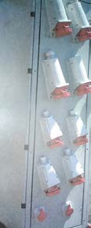
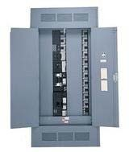
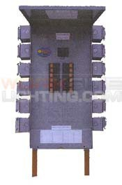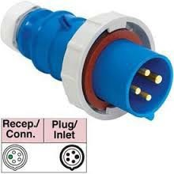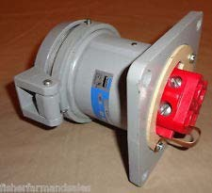

Electric distribution panels complete with 4 pole Male & femalereceptacles.

Flexible electric cables Required

No Qty req Description

1 | 300 mtr | 2awg X 4 core (600 volts)
2 | 500 mtr | 4 awg x 4 core (600 volts)
3 | 2500 mtr | 6 awg x4 core (600 volts)
4 | 600 mtr | 10 awg X 4 core (600 volts)
5 | 2000 mtr | 16 awg X 4 core (600 volts)
6 | 200 mtr | 250mm square /500mcm x 1 core
7 | 1000 mtr | 2/0 awg x 1`core ground cable
8 | 30 each | Flood lights 400 watts 220 Volts (Mercury lamp)
9 | 40 EA | Metal termination box 40cm*30cm*20cm

15 ea Master skids 5.50 meters X 11 meters long.

Reference no 10.
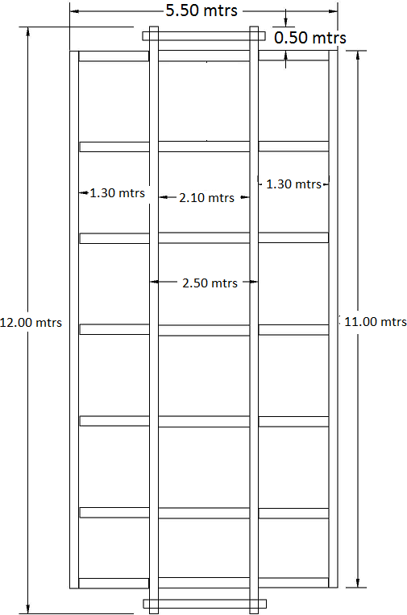

15 | Ea | Master skids 5.50 meters x 11 meters  Long, manufactured from
 |  | Main H-beams 20cm flange and 42 cm web
 |  | Cross beams 20 cm flange 25 cm web
 |  | Master skids have to be sand blassted and painted with 1 coat primer and 2 final coats Black
 |  | Master skids must be built that can be loaded on flat bed winch truck by winch

- Main beam must be manufactured from 20 cm flange 42 cm web
- Cross beams manufactured from 20 cm flange and 25 cm web
- Master skids have to be sand blasted and painted with 1 coat primer and 2 final coats black Paint
- Master skids must be built that we can load them on a bed truck with winch

16

4 units 28 x 10 ft Sleeper/Office 60 Hz .

Reference no 11.

4 Ea 28ft X 10 ft sleeper/office units (1 bed room, office and bathroom) complete with the following
1 Ea 900 x 2000mm Single heavy duty wood beds with bunk light and shelf
- Ea Mattress
- Ea 4 Drawer file cabinet with lock
1 Ea Wardrobe locker, 2 doors
1 Ea 30" x 60" desk double pedestal with lock
1 Ea Dining table 30" x 30"
1 Ea Rectangular coffee table
1 Ea Coffeee maker 36 cups capacity
- Ea Refrigirator 6 cu ft capacity 60 hz
- Ea Steel folding chairs
1 Ea office Swivel chair with arm rest padded seat
4 Ea Waiste basket
- Ea Heavy duty PVC doors between the sleeper rooms and shower room with locks
- Ea Emergency lights,(Sleeper rooms and shower Room)
1 Ea Towel hanger
- Ea Toilet hose
- Ea Smoke detectors
4 Ea Wall plugs in sleeper and office
1 Ea Shower unit fiber glass fabricated that will not allows any water seeping to the sleepers units
1 Ea 80 Liters water heater capacity to be installe outside
1 Ea 600MM X 400 MM Mirrors, lights, soap tray, And shelves
1 Ea 300mm x 300 mm exhaust fan with rain froof vent
- Ea wash hand basin fiber glass (Same as picture)
- Ea LG or Hommer 12,000Btu split unit air condition
220 volts 60 hz

28 X 10 FT 4 men sleeper rig location 60 Hz.

Reference no 12.

2 | Ea | 28ft X 10 ft 4 men sleeper units (2 bed rooms
 |  | and bathroom) complete with the following
4 | Ea | 900 x 2000mm Single heavy duty wood beds
 |  | with bunk light and shelf
4 | Ea | Mattress
4 | Ea | Folding chairs
4 | Ea | Wardrobe locker, 2 doors
2 | Ea | Coat hooks , set of 4
1 | Ea | 80 liters water heater, to be installed out side
1 | Ea | 600 X 400MM Mirrors, lights, soap tray
 |  | and shelves
1 | Ea | 300 x 300mm Exhaust fan with rain proof vent
2 | Ea | LG or Hommer 12,000 BTU split type air condition, 60Hz
1 | Ea | Wash hand basin fiber glass (Same as picture
4 | Ea | Waiste basket
2 | Ea | Heavy duty PVC doors between the sleeper  rooms and shower room with locks
3 | Ea | Emergency lights,(Sleeper rooms and shower  Room)
4 | Ea | Wall plugs in sleepers
1 | Ea | Shower unit fiber glass fabricated that will not
 |  | allows any water seeping to the sleepers units
1 | Ea | Towel hanger
1 | Ea | Toilet hose
1 | Ea | Smoke detectors

2 Men sleeper Rig location 60hz.

Reference no 13.

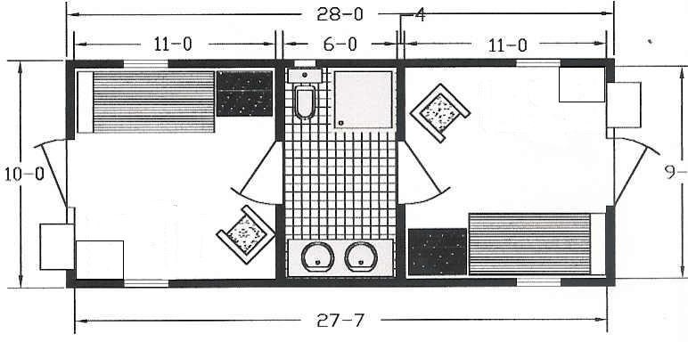

1 | Ea | 28ft X 10 ft 2 men sleeper units (2 bed rooms
 |  | and bathroom) complete with the following
2 | Ea | 900 x 2000mm Single heavy duty wood beds
 |  | with bunk light and shelf
2 | Ea | Mattress
2 | Ea | Folding chairs
2 | Ea | Wardrobe locker, 2 doors
2 | Ea | Coat hooks , set of 4
1 | Ea | 80 liters water heater, to be installed out side
1 | Ea | 600 X 400MM Mirrors, lights, soap tray
 |  | and shelves
1 | Ea | 300 x 300mm Exhaust fan with rain proof vent
2 | Ea | LG or Hommer 12,000 BTU split type air condition, 60Hz
1 | Ea | Wash hand basin fiber glass (Same as picture
4 | Ea | Waste basket
2 | Ea | Heavy duty PVC doors between the sleeper  rooms and shower room with locks
3 | Ea | Emergency lights,(Sleeper rooms and shower  Room)
2 | Ea | Small fridge 6 cu ft, 60 Hz
4 | Ea | Wall plugs in sleepers
1 | Ea | Shower unit fiber glass fabricated that will not
 |  | allows any water seeping to the sleepers units
1 | Ea | Towel hanger
1 | Ea | Toilet hose
1 | Ea | Smoke detectors
2 | Ea | 30" x 60" desk double pedestal with lock
2 | Ea | Swivel office chairs

CLINIC /sleeper 50 Hertz Camp location.

Reference no 14.
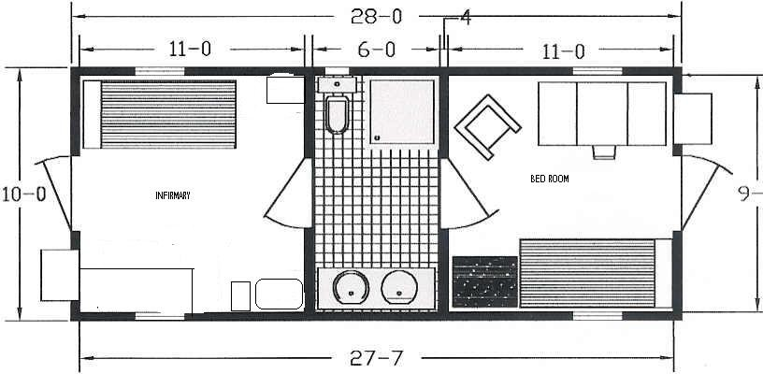

1 Ea 28ft X 10 ft sleeper/infirmary units (1 bed room,
infirmary and bathroom) complete with the following

1 | Ea | 900 x 2000mm Single heavy duty wood beds
 |  | with bunk light and shelf
1 | Ea | Mattress
1 | Ea | 4 Drawer file cabinet with lock
1 | Ea | Wardrobe locker, 2 doors
1 | Ea | 30" x 60" desk double pedestal with lock
1 | Ea | Examination table
1 | Ea | Rectangular coffee table
1 | Ea | Coffeee maker 36 cups capacity
1 | Ea | Refrigirator 12 cu ft capacity 50 hz
2 | Ea | Steel folding chairs
1 | Ea | office Swivel chair with arm rest padded seat
2 | Ea | Waiste basket
2 | Ea | Heavy duty PVC doors between the sleeper  rooms and shower room with locks
3 | Ea | Emergency lights,(Sleeper rooms and shower  Room)
1 | Ea | Towel hanger
1 | Ea | Toilet hose
2 | Ea | Smoke detectors
4 | Ea | Wall plugs in sleeper and office
1 | Ea | Shower unit fiber glass fabricated that will not
 |  | allows any water seeping to the sleepers units
1 | Ea | 80 Liters water heater capacity to be installe
 |  | outside
1 | Ea | 600MM X 400 MM Mirrors, lights, soap tray, And shelves
1 | Ea | 300mm x 300 mm exhaust fan with rain froof vent
1 | Ea | wash hand basin fiber glass (Same as picture)
2 | Ea | LG or Hommer 12,000Btu split unit air condition
 |  | 220 volts 50 hz

28ft X 10 ft Meeting room Rig location 60 Hz.

Reference no 15.

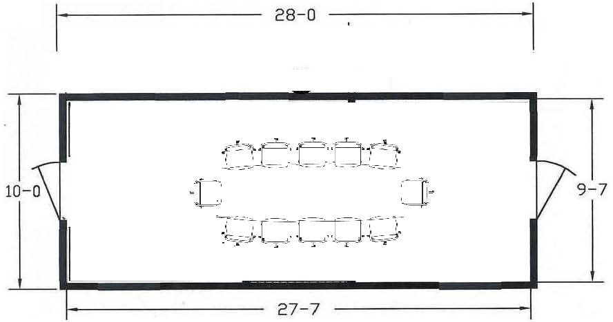

1 | Ea | 28 ft x 10 ft meeting room complete with
5 | Ea | Meeting room table
2 | Ea | LG or Hommer 12,000 Btu split typoe air conditions
2 | Ea | 220 volts, 50 Hz single phase Meeting table for 12 people
12 | Ea | Swivel chairs
10 | Ea | folding chairs
3 | Ea | Emergency lights
1 | Ea | 42" Led tv
1 | Ea | TV Table
1 | Ea | 300MM x 300MM exhaust fan

Floor details sample
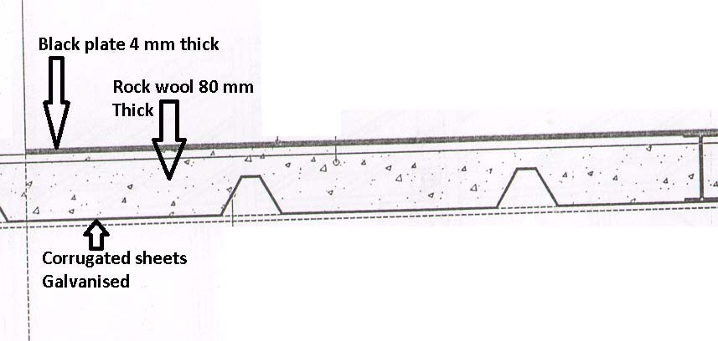

ROOF AND EXTERNAL WALLS DETAILS

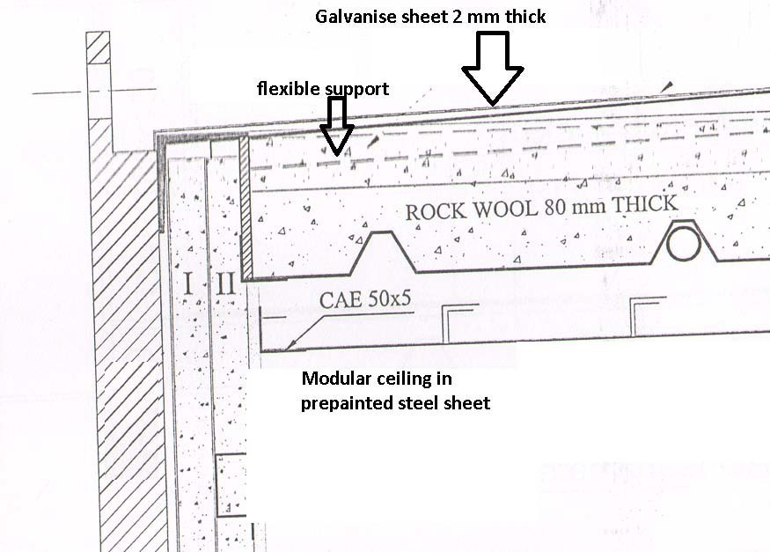

Skid and building base sample
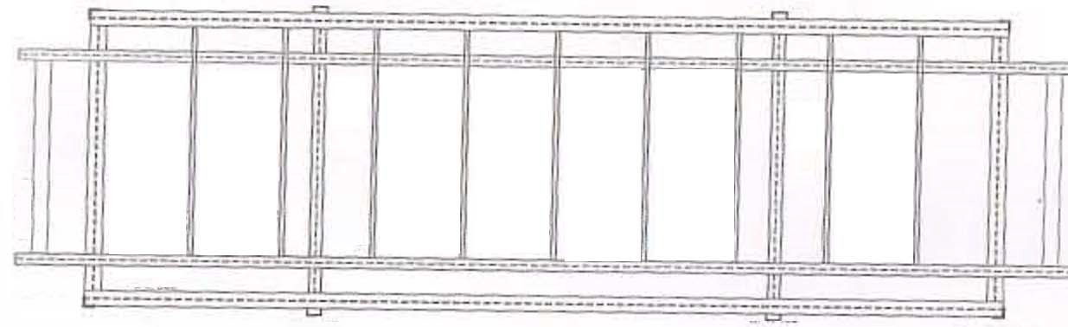

Building body sample
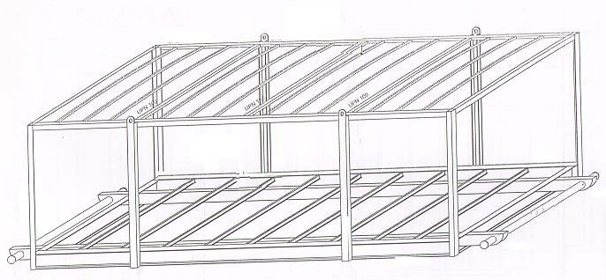

Deep Freeze Unit
Deep Freeze units and control panels

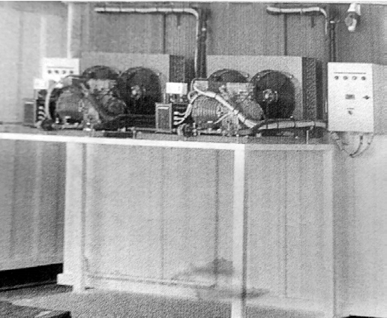
Generator

Deep freeze internal unit

