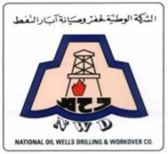
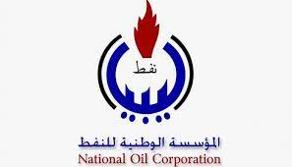
الشركة الوطنية لحفر وصيانة ابار النفط
National Oil Well Drilling and Work over Company
احدى شركات المؤسسة الوطنية للنفط
An N.O.C Company.

Drill Pipes Specification.

Our Ref :NWD-TC-2021-T-50-04.
ITEM # | Qty | UOI | DESCRIPTION
1 | 500 | JTS | DRILL PIPES-3-1/2" O.D. X 2.602" I.D.  GRADE-G 105, Range -II, 15.5 lbs/ft  Tool joint OD 5" X 2-1/8”  Connection pin and box NC-38 (3-1/2" IF)  Pin tong space 10 inches  Box Tong space 12-1/2” inches  with smooth tungsten carbide hardbanding  with 18 degrees taper  TK internal plastic coating  wall thickness 0.449  As per API  Steel thread protectors should be installed on pin and box  GENERAL NOTES FOR DRILL PIPES:  - Length of each drill pipe with tool joint attached should be in the range of 9.14 m to 9.44 m (30 ft. - 31 ft.) measured from shoulder to shoulder. Internal coating should be with TK- 34 / DPC to be applied all along the pipe length.  - Drill pipes must be manufactured as per API Spec. 5D latest edition and must bear API monogram. A copy of valid API Spec. 5D certificate from manufacturer shall be submitted along with the offer.  - The drill pipes shall be brand new, unused and of prime quality. The remaining body wall thickness at any place shall be 95%.  - Drill pipe shall be seamless with weld on type tool joints as per API Spec. 7 and RP 7G latest editions. A copy of valid API Spec. 7 certificate from manufacturer shall be submitted along with the offer/ materials.  - Drill pipes shall be supplied with pressed steel thread protector or composite type Drilltec make closed end thread protectors at both ends  - The offer must contain TK-34/ DPC internal coating to be applied on the drill pipes giving full details of the process of application.  - External coating on the drill pipes shall be done as per relevant API specification. Also drill pipes shall be adequately oiled to withstand sea voyage/ weather condition.

